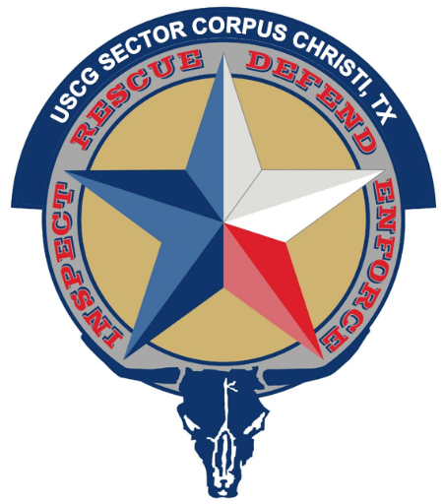

Marine Safety Information Bulletin

14-24, Update 1

Worksite – Corpus Christi Ship Channel

Issue Date: April xx, 2024

SR Trident has informed the U.S. Coast Guard of a time extension of the scheduled submerged pipeline removal crossing the Corpus Christi Ship Channel, between mile markers 55 and 56, from April 15, 2024 through May 31st, 2024 between the hours of 8pm and 6am of the next day, every day. This operation may impact navigation and may require vessels to take appropriate action for the protection of personnel, vessels, and the marine environment. The COTP is establishing a safety zone within the following coordinates: 27° 48' 47.41"N, 97° 16' 49.55"W; 27° 48' 46.55"N, 97° 16' 54.8"W; 27° 48' 28.48"N, 97° 16' 58.94"W; 27° 48' 28.04"N, 97° 16' 51.42"W. No vessels should transit through the safety zone without coordinating through the U.S. Coast Guard.

The M/V CAPT TIMMY and M/V HADLEE GRACE will be monitoring VHF Channel 16 and working on VHF Channel 19.

Concerned parties with urgent concerns can contact the U.S. Coast Guard Sector Corpus Christi Command Center at 1-800-874-2143; or for non-urgent questions and concerns, email CCWaterways@uscg.mil.

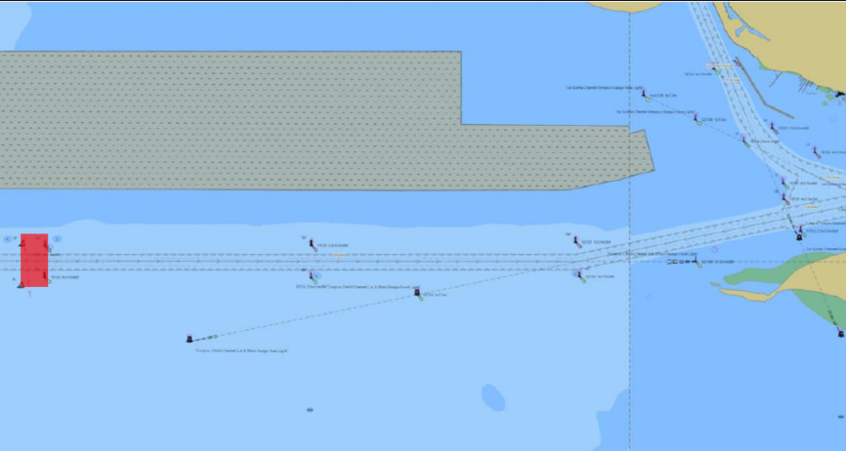

M. W. METZ
Commander, U.S. Coast Guard
Sector Corpus Christi
By Direction of the Captain of the Port

