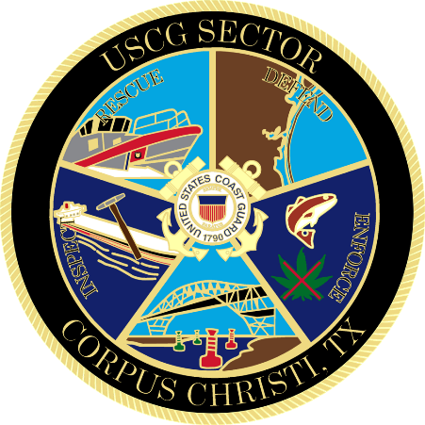

Marine Safety Information Bulletin

xx-24

Safety Zone – V-144 Jackup Rig Movement

Issue Date: April xx, 2024

The Captain of the Port will establish a moving safety zone 500 yards around the V-144 jackup rig in the La Quinta Ship Channel and Corpus Christi Ship Channel as it is transported from the sea buoy to Kiewit Offshore Services on April 9th, 2024. The moving safety zone is needed to protect personnel, vessels, and the marine environment from potential hazards created by the movement of the V-144 jackup rig. The transit is expected to begin at 7 A.M. and be completed by 3 P.M.

No vessel may enter the safety zone and vessels shall not attempt to meet or overtake the V-144 rig during transit.

Concerned parties with urgent concerns can contact the U.S. Coast Guard Sector Corpus Christi Command Center at 1-800-874-2143; or for non-urgent questions and concerns, email CCWaterways@uscg.mil.

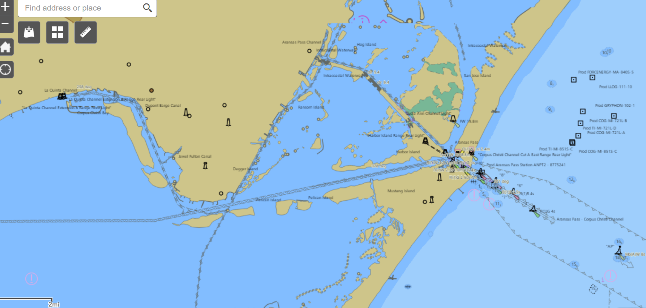

M. Metz
Commander, U.S. Coast Guard
By Direction of the Captain of the Port

